24CSEN2001P: DATA STRUCTURES LAB

CASE STUDY: National Blood and Organ Donation Network

Submitted in partial fulfilments for the degree of
Bachelor of Technology
(Computer Science and Engineering)


By
A.VENKATA GAYATHRI HARSHMITHA ( 2024040399)

BONDI VENKATA LIKHITA ( 2024002556 )

G.HASINI ( 2024109451 )
PEDDINA MOHITHA ( 2024113620 )
BOTTA SNEHITHA ( 2024131891 )

INDEX:

S.No | Content | Page Number
1. | Title | 1
2. | Index | 2
3. | Abstract | 3
4. | Introduction | 3
5. | Methodology/  Architecture | 4
6. | Program(s) | 5-14
7. | Results | 15-22
8. | Conclusion | 23
9. | Reference | 23

ABSTRACT:
- The National Blood and Organ Donation Network is a digital platform designed to connect donors, recipients, and hospitals in real time.
- The system aims to reduce delays in locating compatible donors and ensure timely medical support. It provides a secure database for donor registration, organ availability tracking, and blood stock management.
- This case study highlights how technology can save lives through efficient data management and network communication between healthcare institutions.

INTRODUCTION:
- The shortage of blood and organs is a major challenge in the healthcare system. Many lives are lost due to delays in finding compatible donors. This case study focuses on developing a centralized digital system that manages donor and recipient data efficiently.
- Objectives:
- To create a centralized donor–recipient matching system.
- To minimize the time taken to locate and contact donors.
- To maintain real-time availability data of blood and organs.
- To encourage voluntary donations through awareness.

METHODOLOGY/ARCHITECTURE:

- The system includes several modules such as user registration, database management, matching algorithm, notification system, and admin dashboard. The system architecture allows donors and patients to be connected through a centralized database with a matching engine that calculates compatibility scores based on medical and geographical data.

PROGRAM(S):
- Below is the C program implementation for donor–recipient matching based on multiple criteria such as blood group, organ type, health, and distance:

#include <stdio.h>
#include <string.h>
#include <math.h>

#define MAX 10
#define PI 3.14159265358979323846
#define EARTH_RADIUS 6371 // in kilometers

// ===== STRUCTS =====
struct Donor {
char name[20];
char blood[5];
char organ[10];
int age;
char health[10];
int available;
char location[20];
};

struct Patient {
char blood[5];
char need[10];
int age;
char location[20];
};

struct Match {
char name[20];
float score;
float distance;
float finalScore;
};

// ===== BLOOD COMPATIBILITY CHECK =====
int compatible(char donor[], char patient[]) {
if (strcmp(donor, "O-") == 0) return 1;
if (strcmp(donor, "O+") == 0 &&
(strcmp(patient, "O+") == 0 || strcmp(patient, "A+") == 0 || strcmp(patient, "B+") == 0 || strcmp(patient, "AB+") == 0)) return 1;
if (strcmp(donor, "A-") == 0 && (patient[0] == 'A' || (patient[0] == 'A' && patient[1] == 'B'))) return 1;
if (strcmp(donor, "A+") == 0 && (strcmp(patient, "A+") == 0 || strcmp(patient, "AB+") == 0)) return 1;
if (strcmp(donor, "B-") == 0 && (patient[0] == 'B' || (patient[0] == 'A' && patient[1] == 'B'))) return 1;
if (strcmp(donor, "B+") == 0 && (strcmp(patient, "B+") == 0 || strcmp(patient, "AB+") == 0)) return 1;
if (strcmp(donor, "AB-") == 0 && (strcmp(patient, "AB-") == 0 || strcmp(patient, "AB+") == 0)) return 1;
if (strcmp(donor, "AB+") == 0 && strcmp(patient, "AB+") == 0) return 1;
return 0;
}

// ===== COORDINATE FUNCTIONS =====
float getLatitude(char city[]) {
if (strcmp(city, "Delhi") == 0) return 28.6139;
if (strcmp(city, "Mumbai") == 0) return 19.0760;
if (strcmp(city, "Bangalore") == 0) return 12.9716;
if (strcmp(city, "Chennai") == 0) return 13.0827;
if (strcmp(city, "Hyderabad") == 0) return 17.3850;
if (strcmp(city, "Kolkata") == 0) return 22.5726;
return 0;
}

float getLongitude(char city[]) {
if (strcmp(city, "Delhi") == 0) return 77.2090;
if (strcmp(city, "Mumbai") == 0) return 72.8777;
if (strcmp(city, "Bangalore") == 0) return 77.5946;
if (strcmp(city, "Chennai") == 0) return 80.2707;
if (strcmp(city, "Hyderabad") == 0) return 78.4867;
if (strcmp(city, "Kolkata") == 0) return 88.3639;
return 0;
}

// === DISTANCE (HAVERSINE FORMULA) ===
float toRadians(float degree) {
return degree * (PI / 180.0);
}

float distance(char city1[], char city2[]) {
float lat1 = getLatitude(city1);
float lon1 = getLongitude(city1);
float lat2 = getLatitude(city2);
float lon2 = getLongitude(city2);

float dLat = toRadians(lat2 - lat1);
float dLon = toRadians(lon2 - lon1);

float a = sin(dLat / 2) * sin(dLat / 2) +
cos(toRadians(lat1)) * cos(toRadians(lat2)) *
sin(dLon / 2) * sin(dLon / 2);
float c = 2 * atan2(sqrt(a), sqrt(1 - a));
return EARTH_RADIUS * c;
}

// ===== COMPATIBILITY SCORE =====
float score(struct Donor d, struct Patient p) {
if (!compatible(d.blood, p.blood)) return 0;
float s = 40; // blood type
if (strcmp(d.organ, p.need) == 0) s += 30;
int diff = abs(d.age - p.age);
s += (diff <= 10) ? 15 : (diff <= 20) ? 10 : (diff <= 30) ? 5 : 0;
s += (strcmp(d.health, "Excellent") == 0) ? 10 : (strcmp(d.health, "Good") == 0) ? 7 : 4;
if (d.available) s += 5;
return s;
}

// ===== QUICKSORT =====
void swap(struct Match* a, struct Match* b) {
struct Match temp = *a;
*a = *b;
*b = temp;
}
int partition(struct Match arr[], int low, int high) {
float pivot = arr[high].finalScore;
int i = low - 1;
for (int j = low; j < high; j++) {
if (arr[j].finalScore > pivot) {
i++;
swap(&arr[i], &arr[j]);
}
}
swap(&arr[i + 1], &arr[high]);
return i + 1;
}
void quickSort(struct Match arr[], int low, int high) {
if (low < high) {
int pi = partition(arr, low, high);
quickSort(arr, low, pi - 1);
quickSort(arr, pi + 1, high);
}
}

// ===== MAIN MATCHING ENGINE =====
int main() {
struct Donor donors[MAX];
struct Patient patient;
struct Match matches[MAX];
int donorCount, count = 0;

printf("Enter number of donors (max %d): ", MAX);
scanf("%d", &donorCount);

// Input Donor Data
for (int i = 0; i < donorCount; i++) {
printf("\nEnter details for Donor %d:\n", i + 1);
printf("Name: ");
scanf("%s", donors[i].name);
printf("Blood Group (e.g., A+, O-): ");
scanf("%s", donors[i].blood);
printf("Organ Type (e.g., Kidney, Liver): ");
scanf("%s", donors[i].organ);
printf("Age: ");
scanf("%d", &donors[i].age);
printf("Health Status (Excellent/Good/Fair): ");
scanf("%s", donors[i].health);
printf("Available (1 for Yes, 0 for No): ");
scanf("%d", &donors[i].available);
printf("City (Delhi/Mumbai/Bangalore/Chennai/Hyderabad/Kolkata): ");
scanf("%s", donors[i].location);
}

// Input Patient Data
printf("\nEnter Patient Details:\n");
printf("Blood Group: ");
scanf("%s", patient.blood);
printf("Needed Organ: ");
scanf("%s", patient.need);
printf("Age: ");
scanf("%d", &patient.age);
printf("City (Delhi/Mumbai/Bangalore/Chennai/Hyderabad/Kolkata): ");
scanf("%s", patient.location);

// Compute Matches
for (int i = 0; i < donorCount; i++) {
float s = score(donors[i], patient);
if (s > 0) {
matches[count].score = s;
matches[count].distance = distance(donors[i].location, patient.location);
matches[count].finalScore = s - (matches[count].distance / 100); // softer penalty
strcpy(matches[count].name, donors[i].name);
count++;
}
}

if (count == 0) {
printf("\nNo compatible donors found.\n");
return 0;
}

// Sort by Final Score
quickSort(matches, 0, count - 1);

// Display Results
printf("\n=== Best Matches ===\n");
for (int i = 0; i < count; i++) {
printf("%d. %s | Score: %.1f | Distance: %.1f km | Final: %.1f\n",
i + 1, matches[i].name, matches[i].score, matches[i].distance, matches[i].finalScore);
}

return 0;
}

RESULTS:
// ==== INPUT ====
Enter number of donors (max 10): 3
Enter details for Donor 1:
Name: Riya
Blood Group (e.g., A+, O-): A+
Organ Type (e.g., Kidney, Liver): Kidney
Age: 25
Health Status (Excellent/Good/Fair): Excellent
Available (1 for Yes, 0 for No): 1
City (Delhi/Mumbai/Bangalore/Chennai/Hyderabad/Kolkata): Delhi
Enter details for Donor 2:
Name: Rahul
Blood Group (e.g., A+, O-): O+
Organ Type (e.g., Kidney, Liver): Liver
Age: 40
Health Status (Excellent/Good/Fair): Good
Available (1 for Yes, 0 for No): 0
City (Delhi/Mumbai/Bangalore/Chennai/Hyderabad/Kolkata): Mumbai
Enter details for Donor 3:
Name: Sneha
Blood Group (e.g., A+, O-): A+
Organ Type (e.g., Kidney, Liver): Kidney
Age: 32
Health Status (Excellent/Good/Fair): Fair
Available (1 for Yes, 0 for No): 1
City (Delhi/Mumbai/Bangalore/Chennai/Hyderabad/Kolkata): Hyderabad
Enter Patient Details:
Blood Group: A+
Needed Organ: Kidney
Age: 30
City (Delhi/Mumbai/Bangalore/Chennai/Hyderabad/Kolkata): Chennai

// ==== OUTPUT ====
=== Best Matches ===
1. Sneha | Score: 94.0 | Distance: 515.0 km | Final: 88.9
2. Riya | Score: 100.0 | Distance: 1758.0 km | Final: 82.4
3. Rahul | Score: 62.0 | Distance: 1030.0 km | Final: 51.7

WEB APPLICATION RESULTS:
Main Page
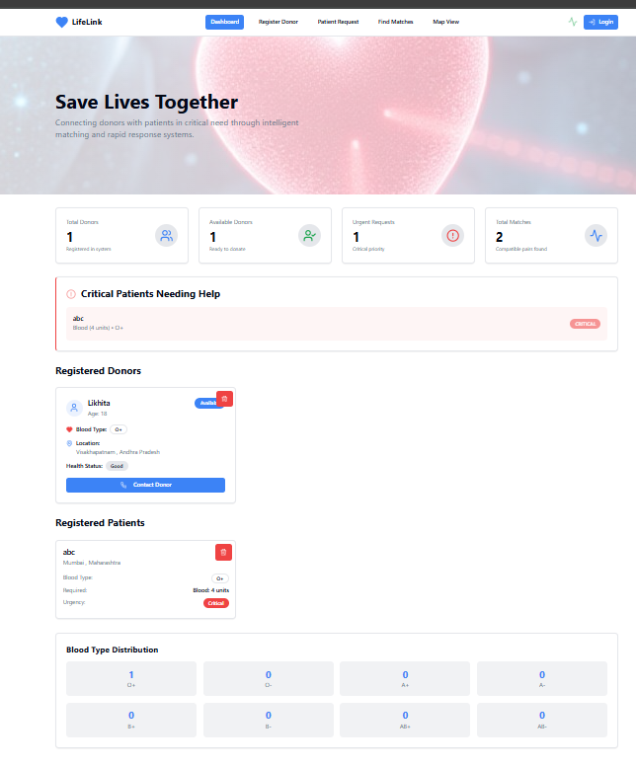
Login and Register Page
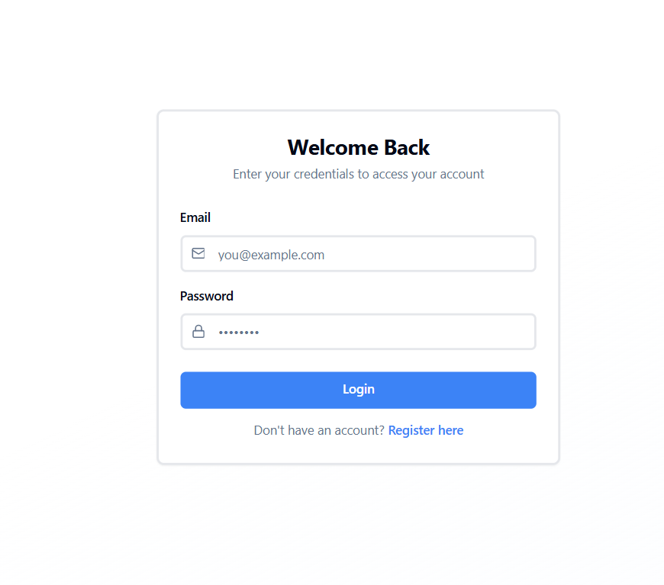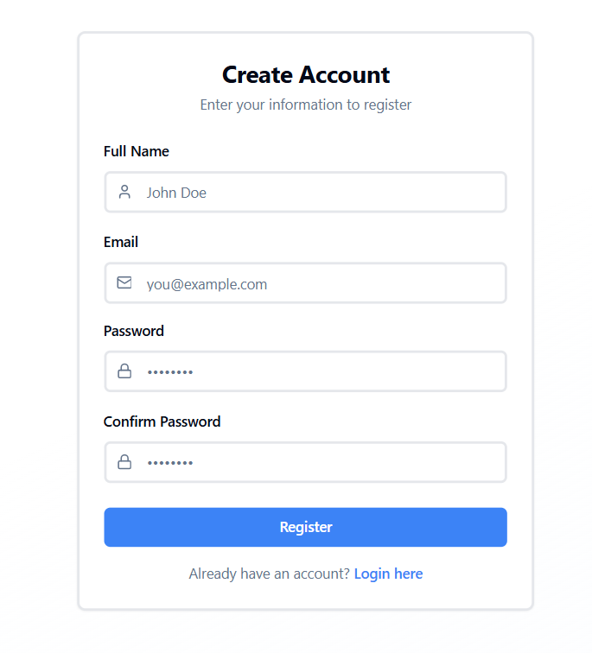

Register as Patient

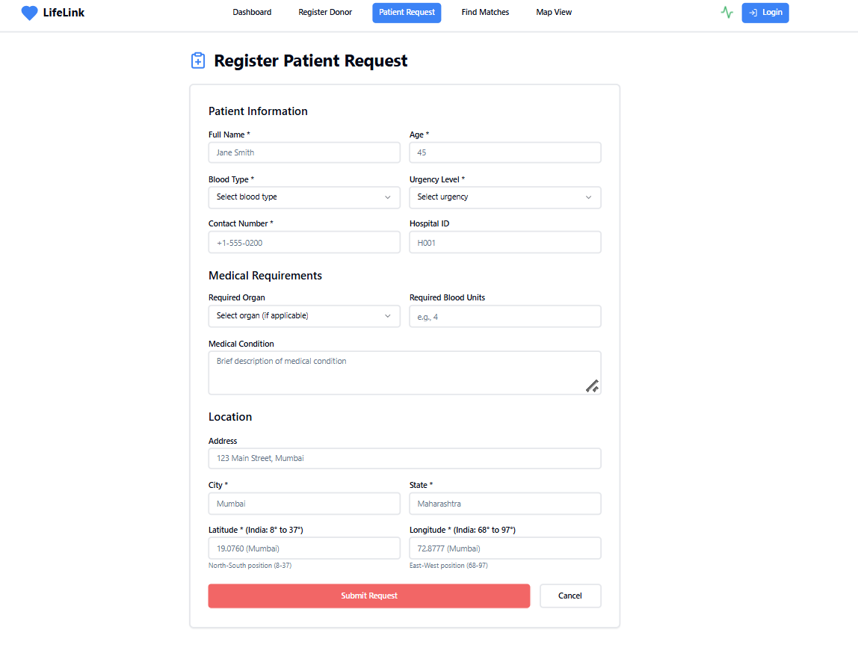
Register as Donor
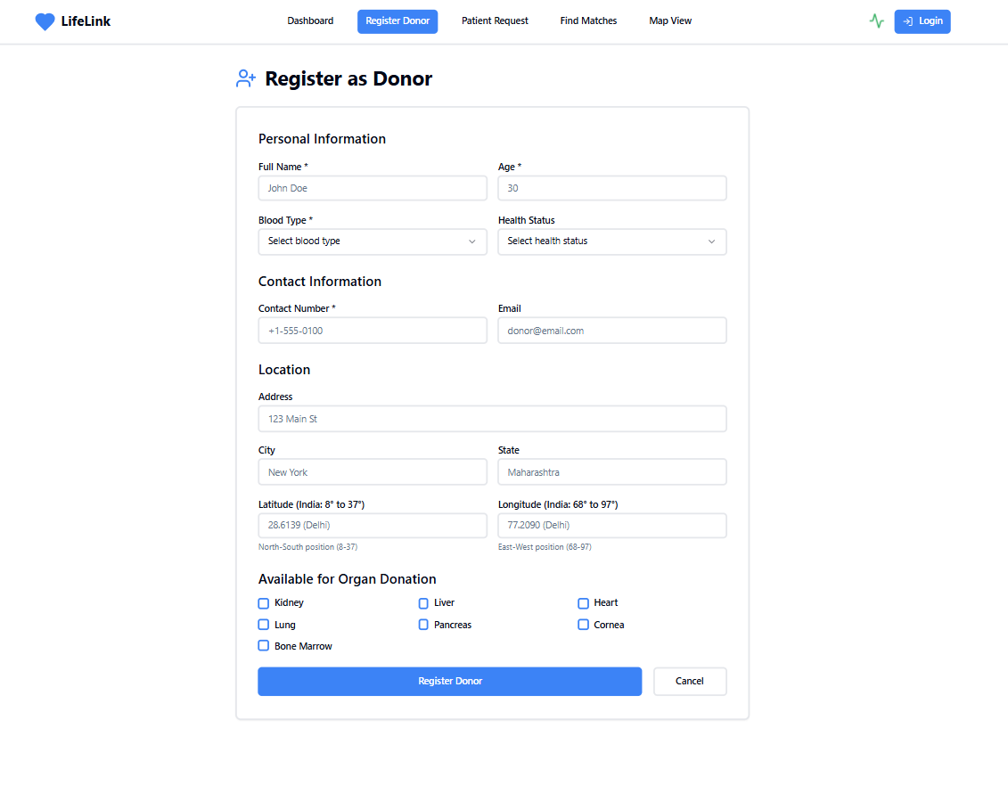

Compatible Donors

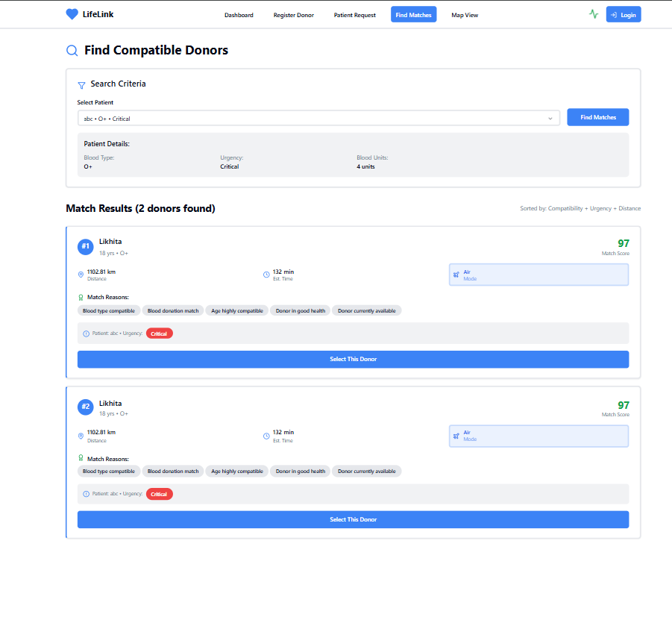

Geographic Distribution (Mao View)
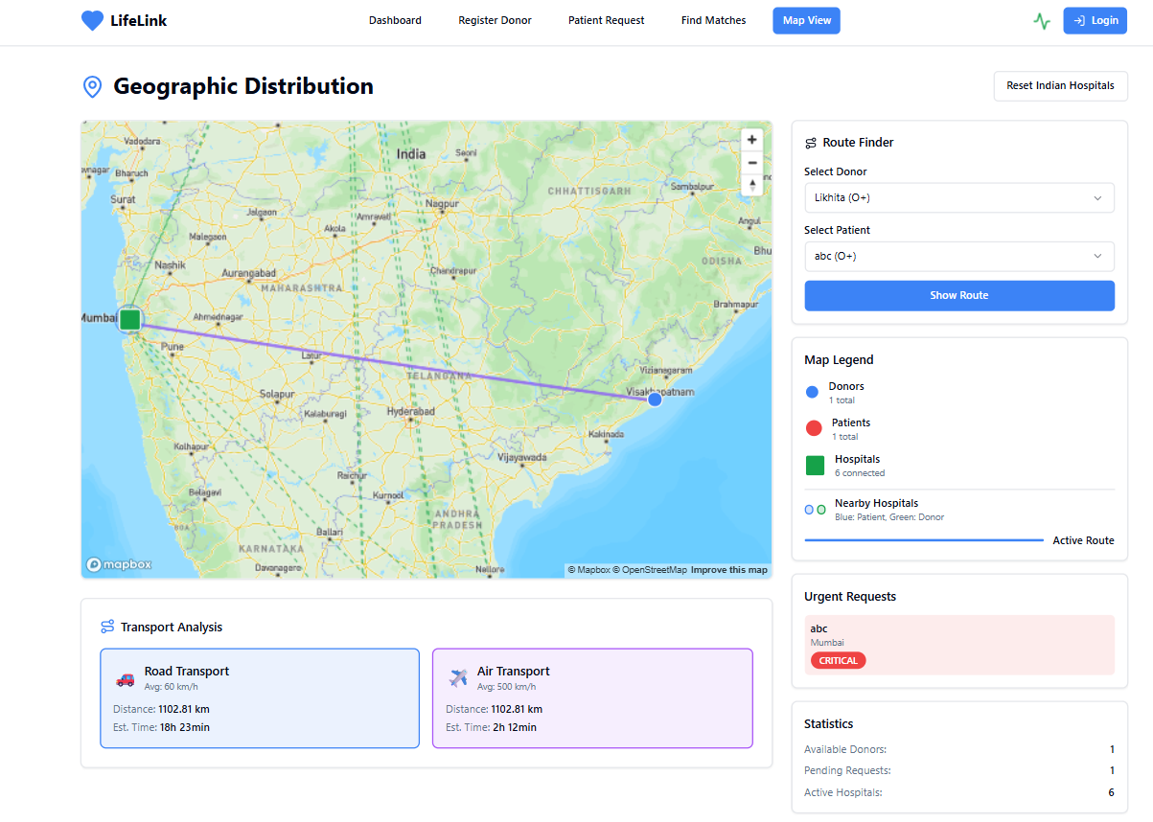
Donor - Visakhapatnam , Patient - Mumbai
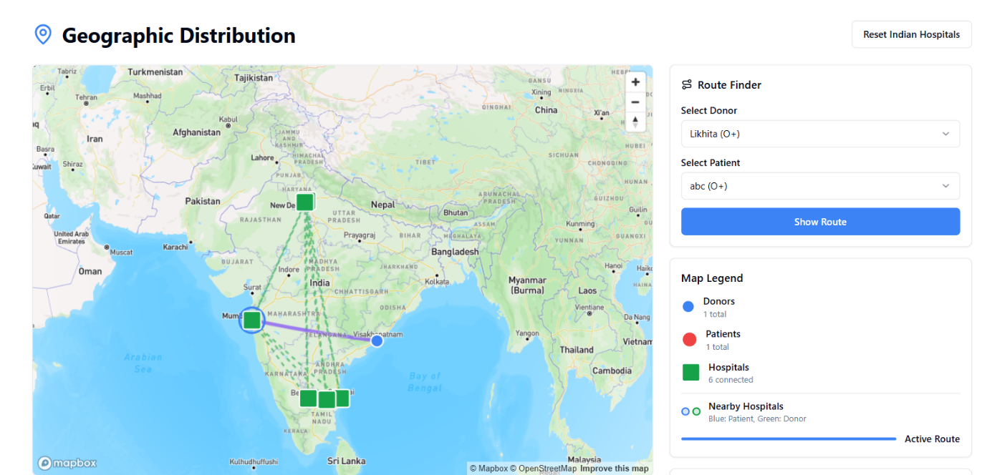

CONCLUSION:

- The National Blood and Organ Donation Network provides a unified digital solution to bridge the gap between donors and recipients. It enhances efficiency, reduces response time, and saves lives. Future versions can include features like GPS-based donor tracking, AI-based compatibility prediction, and mobile app integration for accessibility.

REFERENCES:

[1] https://www.nhp.gov.in
[2] //www.who.int/health-topics/blood-safety
[3] https://www.geeksforgeeks.org

